

Department of

Bachelor of Computer Applications

**Ethical Hacking Fundamentals**

Lab File – CA 08

**Subject Code:** 19BCA4C02L

**Class:** IInd Year IInd Semester

**Prepared By:**

Suman Garai

20BCAR0246

**Aim :**

Perform NMAP Scan on Metasploitable Web, IP Subnet using Kali Linux and Windows**.**

**Requirements :**

* Virtualisation Software
* Kali Linux 2021.4a
* Basics of Nmap
* Internet Connection

**Objectives :**

To Run different scans :

* TCP Null Scan
* UDP Port Scan
* Nmap Packet Trace

**Procedure :**

Basics

Zenmap is an Nmap frontend. It is meant to be useful for advanced users and to make Nmap easy to use by beginners. It was originally derived from Umit, an Nmap GUI created as part of the Google Summer of Code. This application runs in a container via kaboxer.

1. Open root terminal in kali linux, and run the command sudo apt install zenmap-kbx to install zenmap.
2. Launch the application by searching zenmap from Applications button in taskbar or typing zenmap-kbx in terminal.

The window appears like this. There are areas where we can input target, command, use defined profiles, see rescan results and start scan button.

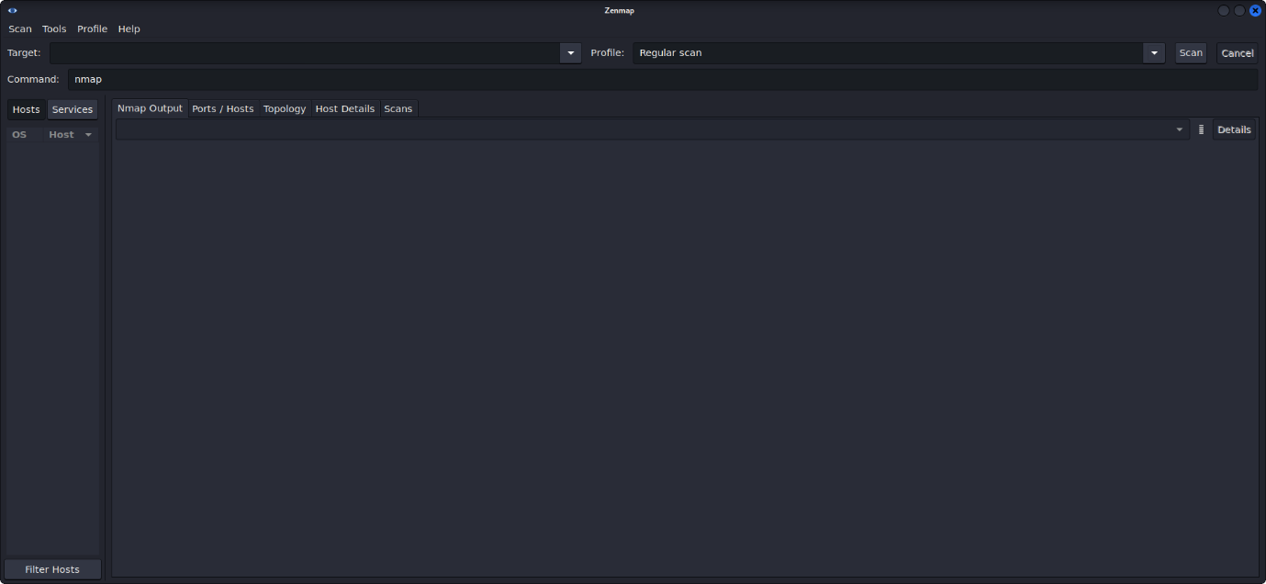

TCP Null Scan

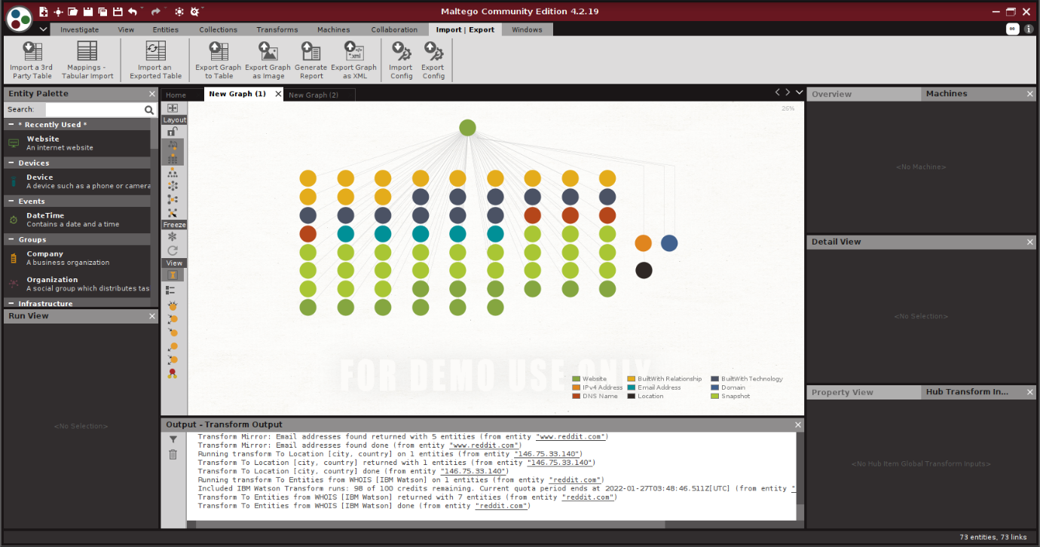Command: nmap -T4 -A -v <IP Address>

As we ca see, in this zoomed out version, all types of information obtained are classified according to its types in the index.

NOTE: For more details regarding the information obtained, head over to: <https://drive.google.com/drive/folders/19upnHnKXo7k3vXxKCR5QyL6FecHu3UJD?usp=sharing>

DNS Information

1. Following similar step, as did while obtaining information from website, we end up with the website entity being shown in a blank graph.
2. Right-click and select Double Arrow of ‘Convert to Domain’ from the drop down Run Transforms, and we get the Domain Entity stating redddit.com.
3. Again, Right-click and select Double Arrow of ‘All Transforms’ from the drop down Run Transforms, to obtain detalis like: Domain, People, Emails, Phone Numbers, Documents, Locations, MX & NS Records, Company, IP Addresses etc.
4. Set the duartion range in the wayabck machine section, to obtain links of older versions of the site. Click ‘Run!’.

Information obtained are as follows:

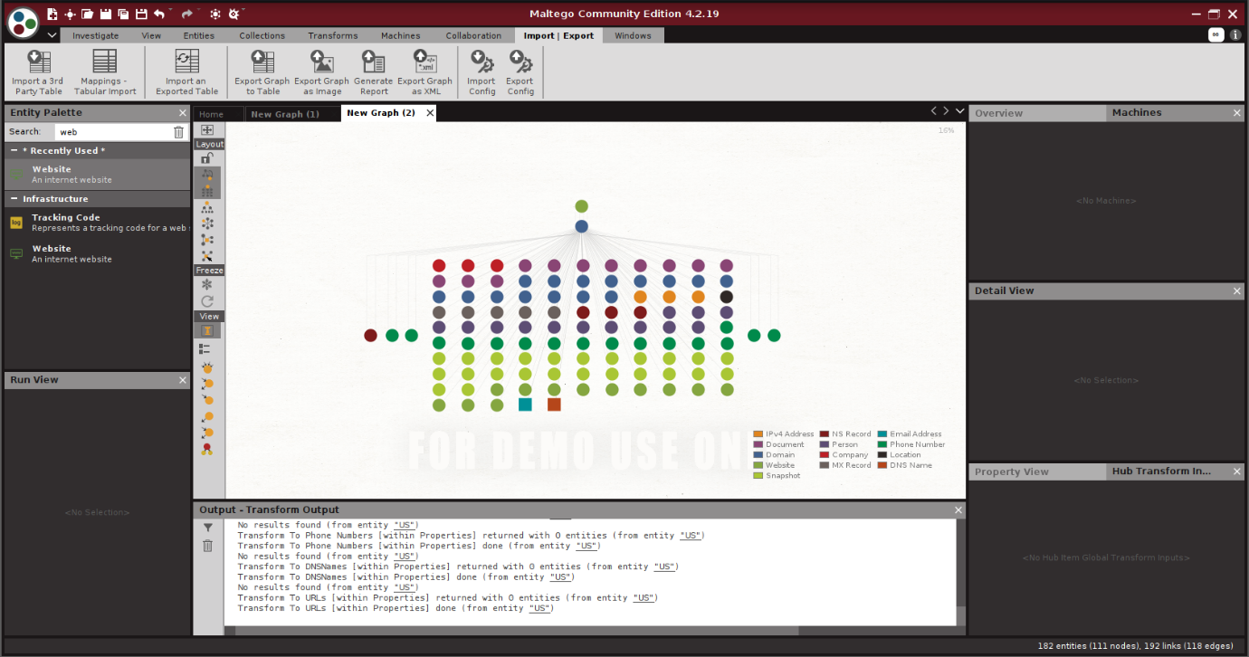

As we ca see, in this zoomed out version, all types of information obtained are classified according to its types in the index.

NOTE: For more details regarding the information obtained, head over to: <https://drive.google.com/drive/folders/1PvKTzPNR2Tdourk8g27YUt9pwrmYPSUn?usp=sharing>

To Generate Reports

After reguired information in obtained at the graph, head over to ‘Import/ Export’ from the Tabs Section. Different options for exporting graphs are present there, like:

Export graph to Table

1. Selecting Export Graph to Table option provides us with a wizard.
2. In Setting Step, select whole graph from export section, check remove duplicates, select human/ machine readable as wish and check separate link file. Click Next.
3. In Select File Step, change to the desired location where we want our graph to be saved, putting desired file name and selecting desired file type. Click Next.
4. It now, displays the changelog. Click Finish.

Export graph as Image

1. Selecting Export Graph as Image option provides us with a dialog box.
2. Change the desired saving loaction of the file, provide filename, change the file type as wish, set image zoom to any value above 100 and image bounds to whole graph.

Click Save.

Generate Report

1. Selecting Generate Report option provides us with a dialog box.
2. Change the desired saving loaction of the file, provide filename, change the file type as wish, set graph image bounds to whole graph and check all include options. Click Save.

**Conclusion :**

Maltego is a powerful tool, you can extract a broad type of information through the network, technologies, and personnel (email, phone number, twitter).

By extracting all this information, an attacker can perform different type of malicious activity.

The built-in technologies of the server: attackers might search for vulnerabilities related to any of them and simulate exploitation techniques.

SOA information: also, can be useful for attackers, they can abuse this information to find vulnerabilities in their services and architectures and exploit them.

Name Server: attackers can exploit NS using malicious techniques like DNS hijacking and URL redirection.

IP addresses: attackers can abuse the IP address by scanning and searching for open ports and vulnerabilities, and thereby attempt to intrude in the network and exploit them.

Geographical location: attackers can perform social engineering attacks to leverage sensitive information.